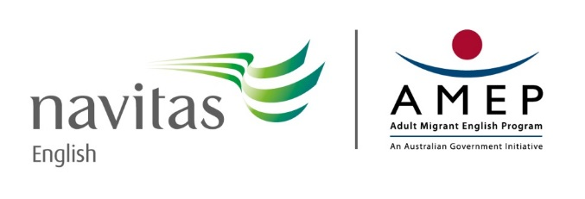

Volunteer Tutor Scheme Overview
Background
For a non-English speaking migrant or refugee, coming to Australia, with no understanding of our language or culture, can be a daunting experience and can lead to a feeling of isolation from the community. The Navitas Volunteer Tutor Scheme’s students come from all over the world: China, Europe, South America, Sudan, Iraq, Afghanistan, India, South Korea, Vietnam and Myanmar, to name but a few.
Purpose
The Navitas Volunteer Tutor Scheme (VTS) exists to help those people who have difficulty attending class and making satisfactory use of the Adult Migrant English Program – AMEP. Some people find it difficult to leave their homes because of family commitments, illness, transport difficulties, shift work or perhaps a lack of confidence. Since they cannot go to classes, the scheme takes learning and opportunities for social contact to them. A few are attending class but special circumstances warrant that they also have a tutor or they may be waitlisted for class but anxious to start learning English to help them settle in.
Training and Support
The VTS Coordinator provides volunteer home tutors with 16 hours of free training, on-going support and resources.
The VTS coordinator is available at any time to discuss the progress of a tutor and student and to offer support or advice. Regular meetings are held for tutors and a VTS news update is emailed at regular intervals.
Volunteer Tutoring
Further information on volunteer tutoring is available by contacting Marcella, the Volunteer Tutor Scheme coordinator on Phone: 9707 0264 or email to: volunteertutor@navitas-english.com.au
The Adult Migrant English Program (AMEP) is funded by the Australian Government Department of Education and Training. In NSW, AMEP is delivered through Navitas.

